Dear Keith,

Many thanks for your recent review of our paper “The AMPeror’s New Clothes: Performance in the Affect Misattribution Procedure is Mainly Driven by Awareness of Influence of the Primes” for JPSP. We were extremely grateful for your extensive, thoughtful, and comprehensive comments. We are currently busy designing one or more studies to address the concerns that you and the second reviewer highlighted.

To ensure that these new studies are of maximum utility, we would like to involve you in the design process and to include our correspondence when preregistering those studies. We only want to run studies that directly speak to your questions and would therefore appreciate your input on the logic of our arguments, our characterisation of the existing literature, and how your concerns can be empirically tested.

One of the main points in your review was that our various experiments (like most other published studies on this topic) failed to eliminate post-hoc confabulation as a potential explanation for AMP effects that are moderated by influence awareness. In other words, by asking participants about the influence of the prime on their target evaluations *immediately after* they had emitted those evaluations, any response to this question may still represent a post hoc confabulation on their part. You also argued that, if so, then our results are consistent with the misattribution account; i.e., “participants can observe their own behavior and notice if they are responding in prime-consistent ways. If so, they can report afterward that they were influenced by the prime”.

We think a relatively simple modification to our existing paradigm would allow us to avoid the issue of post-hoc confabulation. Specifically, in our previous AMP experiments, participants were presented with a prime 🡪 blank screen 🡪 target 🡪 mask (until an evaluative response was emitted). Only after this overt evaluative response were they given the opportunity to emit an influence-awareness response (i.e., indicate if the prime influenced their target evaluation). However, the trial sequence can be altered to eliminate the possibility of post-hoc confabulation. That is, participants can be presented with the target 🡪 blank screen 🡪 target 🡪 giving an opportunity to emit an influence-awareness response 🡪 and only then the opportunity to emit an evaluative response. In this way, the response to the influence-awareness question could not be confabulated with the overt target evaluation, because the influence-awareness judgement is made before the evaluation itself. If you agree, then we propose to run an experiment that is very similar to Experiment 2 in our manuscript but uses an IA-AMP that is modified as described above (see Figure 1). As in Experiment 2, this would examine whether the influence-awareness rate in the IA-AMP is *postdictive* of the absolute magnitude of the AMP effect on a previously completed standard AMP.

*Mask & Evaluative Response*

*Prime*

*Blank Screen*

*Target*

*Prime Influence Question*

***Unpleasant***

***Pleasant***

***Unpleasant***

***Pleasant***

***Pleasant***

***Unpleasant***

***Pleasant***

***Unpleasant***

***Unpleasant***

***Pleasant***



*Press spacebar if the picture will influence your response to the Chinese symbol*

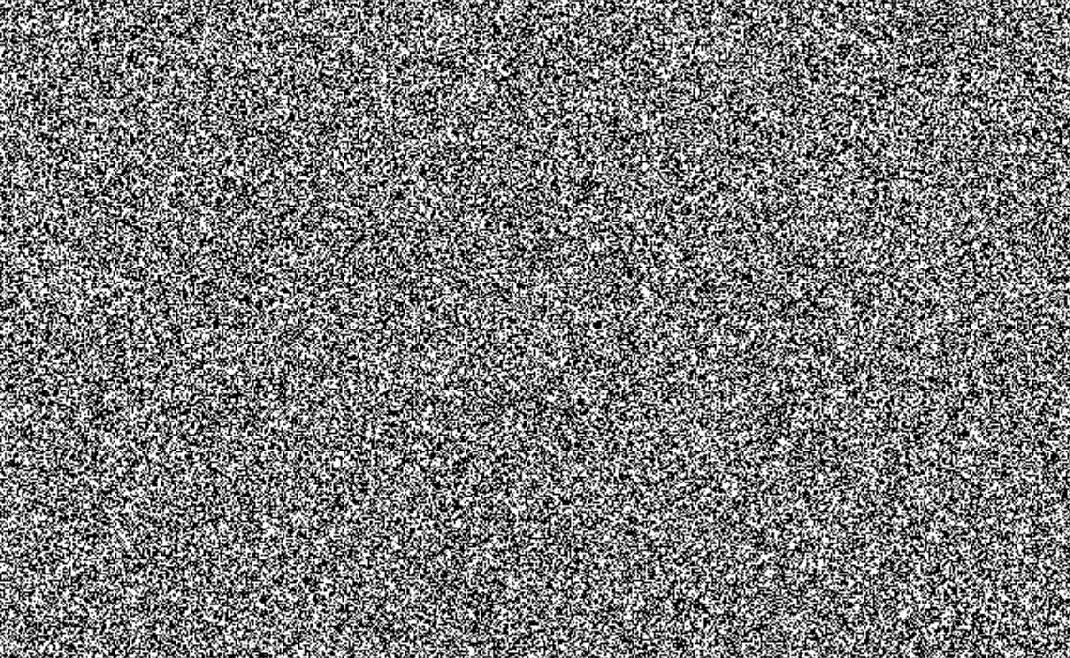

*Figure 1*. Trial sequence for a typical trial in the proposed study.

From our reading of Experiment 3 from Payne et al. (2013), this paradigm wholly aligns with the rationale which you used in the development of your ‘skip’ paradigm (i.e., participants report on influence-awareness prior to giving any evaluative response).

Based on the above description, would you consider this method to effectively overcome the issue of post-hoc confabulation? And if not, what would you consider to be the distinguishing feature between the above paradigm and that used in Experiment 3 of Payne et al. (2013), which you suggested was effective in eliminating trials with prospective awareness?

If you have the opportunity to provide us with any feedback on this revised version of our paradigm, we would greatly appreciate it. You can find the Inquisit script of the revised paradigm attached to this email. We also would like to thank you again for taking the time to review our manuscript and for providing critical and highly useful feedback.

Best regards

Jamie Cummins

Ian Hussey

Sean Hughes